**Project title:** Snakes and Kabootars (HU-themed Snakes and Ladders)

**Group members:**

* Murtaza Ali Khokhar, (mk06352)
* Sudais Yasin (sy06541) and
* Zain Ahmed Usmani (zu06777)

**Project Description:**

Snakes & Kabootars (tentative title) is an interactive single and multi-player game based on snakes and ladders revolving around Habib University and its culture.

At its core it features a map with the regular snakes (as snakes[1]) and ladders (as magical pigeons/kabootars that shorten distances for you), with a 100-step journey that players compete to finish first. Alongside these there are bunch of new additions to the traditional game to make it more fun:

* To decide how far to move, instead of rolling a die, the player would have to timely strike on a moving target (see figure below)

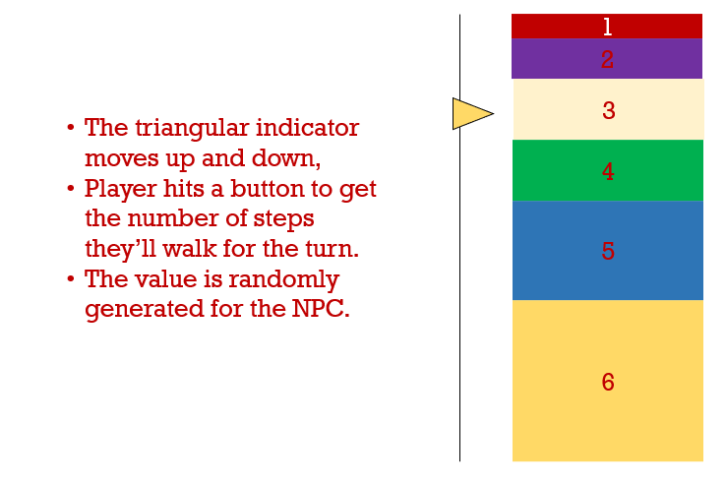

Figure 1 - Interactive tool to replace rolling a die to get number of steps.

* An interactive duel when two players land on the same position (this involves a similar mechanism to the one above, where players strike the target to get a value higher than their opponent)
* A leaderboard to record wins; could involve an implementation of insertion sort
* A non-player character (NPC/adversary/opponent) that tries to find the shortest route to the finishing block[2], given its position. Since every turn will lead to a new position, it may have to recalculate the shortest route per turn and we may have to optimize this.

The game will of course feature an appropriately themed mouse and keyboard based GUI that effectively communicates the comedic nature of the game. The map of the game / game-board (of a 100 steps) will be a graph however, we may choose to add the following functionalities to further experiment with our understanding of DSA:

* Transitions and animations designed using stacks, queues and other data structures
  + We may also conduct experimental analysis with different GUI aspects in order to see if either one may have significant impacts on game performance
* A more developed engine / format to the game that enables the game board to be customized easily. This can enable us to easily create randomized gameboards for each playthrough, i.e. randomly-generated levels from the computer for each playthrough.

**Project Outcome:**

The game is primarily intended to help enable us to successfully build on top of what have learnt through CS102 by implementing it into a functioning program – specifically graphs. The purpose of the game may also become therapeutic or comedic.

**Libraries:**

So far it seems primarily we may only be needing the pygame library; other commonly pre-installed libraries like math, copy and others might also be used. If we are to develop the extra experimental functionalities (e.g., auto-generated gameboard), we may also make use of the random and time libraries.

**Other ideas:**

* The same idea but instead of having a graph with fixed nodes it has nodes that change on every turn (like Harry Potter’s variable staircase that changes unconditionally)
* A website / database scalper that collects and organizes data into a database that can be sorted, filtered and searched through.
  + This has more implementation of DSA concepts from class than our current proposal, but a destressing game with a GUI felt like it would be more fun to make (instructor’s opinion on this and (on whether our current proposal has enough DSA in it) would be appreciated).

Checkers… / Scrabble (lst of words,

1. We may replace snakes with kabootars that may cause you to rush to the nearest restroom (lower node) after pooping on you (as kabootars at HU are infamous for).
2. Uses optimized Dijkstra that can be run multiple times